Experiment:- 12

Problem Statement:-
Manual execution of commands in Linux can be repetitive and inefficient. Bash shell scripting enables users to automate tasks, accept user input, perform arithmetic operations, make decisions using conditional statements, and execute repetitive tasks using loops. These capabilities are essential for system administration, automation, and cyber security workflows.
The problem is to write and execute Bash shell scripts that demonstrate interactive input, positional parameters, arithmetic operations, conditional statements, and loop constructs, thereby automating basic computational and logical tasks.
Aim:- Shell programming using bash: Interactive script, Parameters, Arithmetic operations, Conditional Statement and loops.
Procedure:-
- Interactive Shell Script
1. Create a script file: nano interactive.sh

2. Enter the following code: #!/bin/bash echo "Enter your name:" read name echo "Welcome $name" .Save and exit.
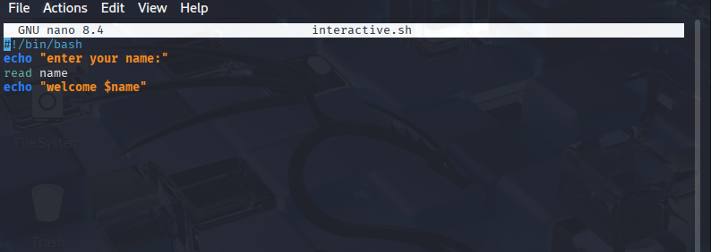

3. Make the script executable: chmod +x interactive.sh

4. Execute the script: ./interactive.sh
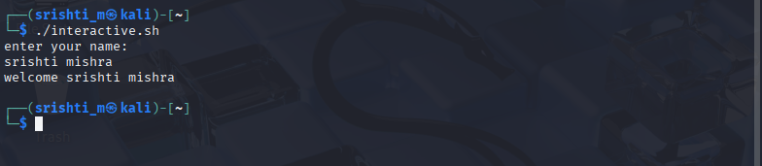

- Script Using Positional Parameters

5. Create another script: nano params.sh

6. Enter the following code: #!/bin/bash echo "Script Name: $0" echo "First Argument: $1" echo "Second Argument: $2"
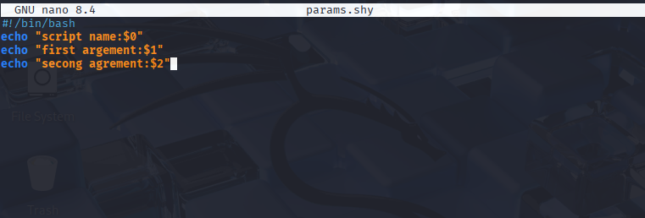

7. Execute: ./params.sh Linux Bash


- Arithmetic Operations

8. Create script: nano arithmetic.sh
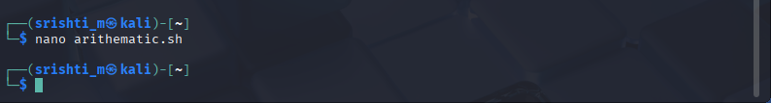

9. Enter: #!/bin/bash a=10 b=5 sum=$((a + b)) echo "Sum = $sum"
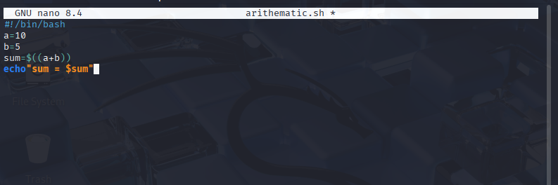

- Conditional Statement

10. Create script: nano condition.sh

11. . Enter: 14. #!/bin/bash . echo "Enter a number:" read num . if [ $num -gt 0 ] then . else fi
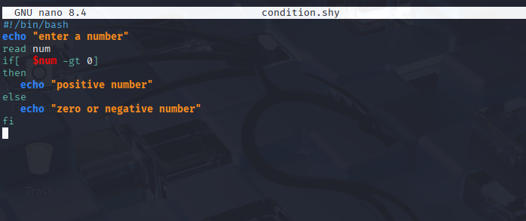

- Loop Constructs
12. Create for-loop script: nano loop.sh

13. Enter: #!/bin/bash . for i in 1 2 3 4 5 . do . done echo "Iteration $i"
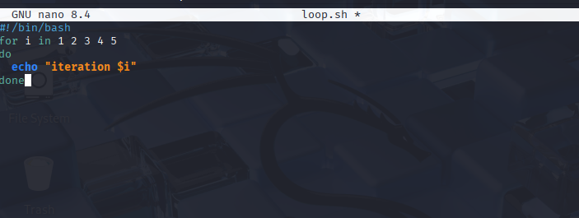

Expected Output
• Scripts accept user input and display results correctly.
• Positional parameters are accessed successfully.
• Arithmetic operations produce correct output.
• Conditional statements and loops execute as expected.
Result
Bash shell scripts demonstrating interactive input, positional parameters, arithmetic operations, conditional statements, and loops were successfully created and executed.

